**600:1 Hydrofluoric Acid**

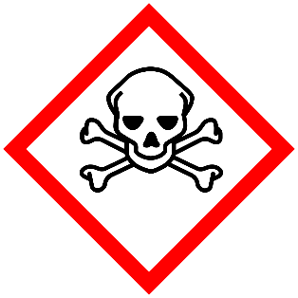

**Danger**

Toxic in contact with skin. Harmful if swallowed.

**600:1 HF**